**Module (HTML) -1**

1. **Are the HTML tags and elements the same thing?**

Ans : No, not same thing.

HTML Tags are the labels that create web pages. Each tag provides special meaning for the content.

**For example: <p> is paragraph tag.**

HTML element is a combination of start tag, content and an end tag. Mostly, website content is written inside start tag (<p>) and an end tag (</p>).

**For example:**

**<p> This is the content of the paragraph element.** </p> represents HTML element.

1. **What are tags and attributes in HTML?**

Ans : HTML Tags are the labels that create web pages. Each tag provides special meaning for the content.

**For example: <p> is paragraph tag.**

HTML Attributes is used to define the character of an HTML element. **Attribute is a special word used inside tag to specify additional information to tag such as colour, alignment etc.**

**For example: <body bgcolor=”red”>**

1. **What are void elements in HTML?**

Ans : There is a special group of elements that only have start tags and does not contain any content within it, these elements are called void elements. Void elements doesn’t have ending tag.

Example of :- [<br>](https://www.geeksforgeeks.org/html-brgt-tag/), [<hr>](https://www.geeksforgeeks.org/html-hr-tag/), [<img>](https://www.geeksforgeeks.org/html-img-tag/), [<input>](https://www.geeksforgeeks.org/html-input-tag/), [<link>](https://www.geeksforgeeks.org/html-link-tag/), [<base>](https://www.geeksforgeeks.org/html-base-tag/), [<meta>](https://www.geeksforgeeks.org/html-meta-tag/) etc.

1. **What are HTML Entities?**

Ans : HTML character entities are used as a replacement of reserved characters in HTML. You can also replace characters that are not present on your keyboard by entities.

These characters are replaced because some characters are reserved in HTML. HTML entities provide a wide range of characters which can allow you to add icons, geometric shapes, mathematical operators, etc.

**For example:** if you use less than (<) or greater than (>) symbols in your text, the browser can mix them with tags that's why character entities are used in HTML to display reserved characters.

1. **What are different types of lists in HTML?**

Ans : There are three list types in HTML:-

* Unordered list — used to group a set of related items in no particular order.
* Ordered list — used to group a set of related items in a specific order.
* Description list — used to display name/value pairs such as terms and definitions.
* Nested list — Combine one or more list

1. **What is the ‘class’ attribute in HTML?**

Ans : The class is an attribute which specifies one or more class names for an HTML element.

The class attribute can be used on any HTML element.

The class name can be used by CSS and JavaScript to perform certain tasks for elements with the specified class name.

1. **What is the difference between the ‘id’ attribute and the ‘class’ attribute of HTML elements?**

Ans : Difference between id and class attribute: The only difference between them is that “id” is unique in a page can only apply to at most one element, while “class” selector can apply to multiple elements.

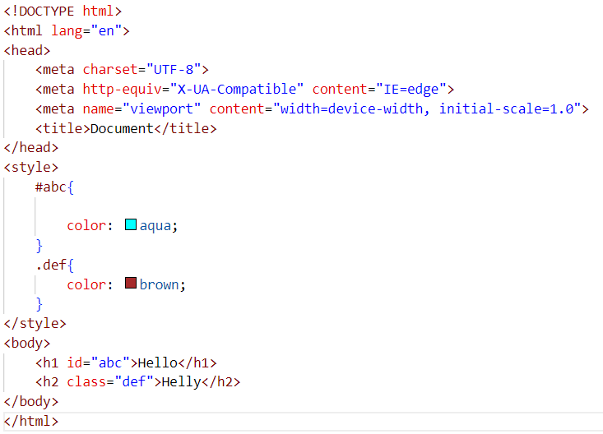

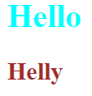

1. **What are the various formatting tags in HTML?**

Ans : below tags are formatting

* <b> - Bold text
* <strong> - Important text
* <i> - Italic text
* <em> - Emphasized text
* <mark> - Marked text
* <small> - Smaller text
* <del> - Deleted text
* <ins> - Inserted text
* <sub> - Subscript text
* <sup> - Superscript text
* <big> - Increase text

1. **How is Cell Padding different from Cell Spacing?**

Ans : Cell padding represent the distance between cell boarders and the content within a cell.

For example:

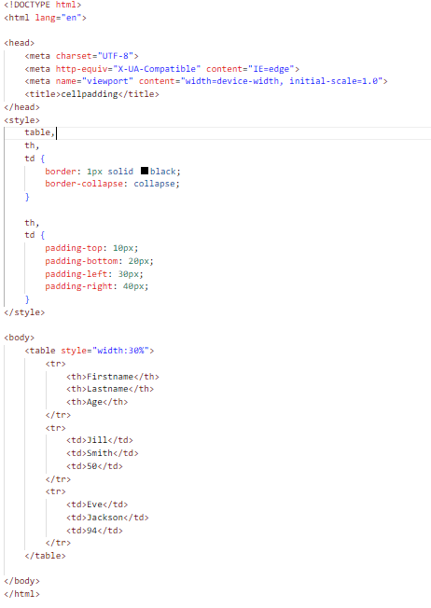

Output:

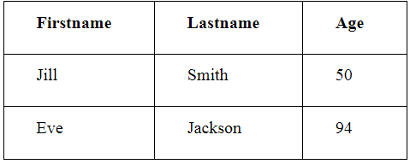

Cellspacing attribute defines space between table cells.

Foe example:

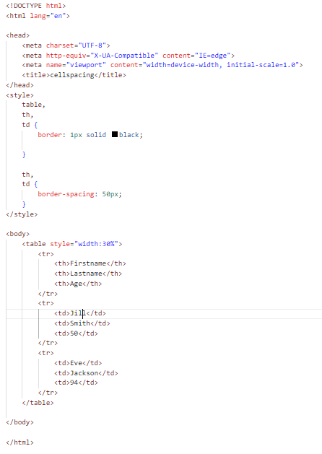

Output:

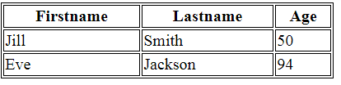

**10**.**How can we club two or more rows or columns into a single row or column in an HTML table?**

Ans : You can merge two or more table cells in a column using the colspan attribute in a <td> HTML tag (table data). To merge two or more row cells, use the rowspan attribute**.**

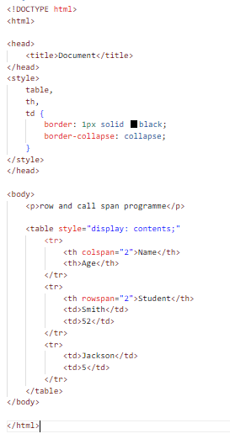

**Output:**

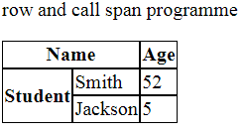

**11. What is the difference between a block-level element and an inline element?**

Ans : Block Elements occupy the full width irrespective of their sufficiency. Block elements always start in a line.

For example: <div>, <dl>,<li>,<p>,<section>.

Inline elements don't start in a new line. Inline elements allow other inline elements to sit behind.

For example: <span>, <em> ,<a>, <img>.

**12. How to create a Hyperlink in HTML?**

Ans : To make a hyperlink in an HTML page, use the <a> and </a> tags, which are the tags used to define the links. The <a> tag indicates where the hyperlink starts and the </a> tag indicates where it ends. Whatever text gets added inside these tags, will work as a hyperlink.

Add the URL for the link in the <a href=” ”>.

For example: <a href="https://www.google.com/">Google</a>

**13.** **What is the use of an iframe tag?**

Ans : The <iframe> tag specifies an inline frame. An inline frame is used to embed another document within the current HTML document.

**14**. **What is the use of a span tag? Explain with example?**

Ans: The <span> tag is an inline container used to mark up a part of a text, or a part of a document.

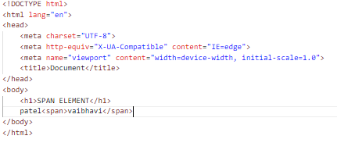

Output:

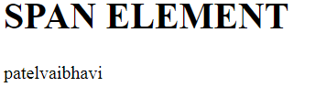

**15. How to insert a picture into a background image of a web page?**

Ans: To set the background image of a webpage, use the CSS style. Under the CSS <style> tag, add the property background-image. The property sets agraphic such as jpg, png, svg, gif, etc.HTML5 do not support the <body> background attribute, so CSS is used to change set background image.

**16. How are active links different from normal links?**

Ans: Those that don't have a mouse cursor over that link is considered a normal link. Some browser recognize active links when the mouse cursor is placed over that link. Others recognize active links when the link has the focus. Those that do not have mouse cursor over the link is said to be normal link.

**17. What are the different tags to separate sections of text?**

Ans:There are three tags that can be used to separate the texts:

<br> tag –: Usually <br> tag is used to separate the line of text. It breaks the current line and conveys the flow to the next line.

<p> tag –: This contains the text in the form of a new paragraph.

<blockquote> tag –: It is used to define a large quoted section.

**18. What is SVG?**

Ans:The <svg> tag defines a container for SVG graphics. SVG has several methods for drawing paths, boxes, circles, text, and graphic images.

**19.What is difference between HTML and XHTML?**

Ans:HTML is SGML-based while XHTML is XML-based. They are like two sides of the same coin. XHTML was derived from HTML to conform to XML standards. Hence XHTML is strict when compared to HTML and does not allow user to get away with lapses in coding and structure.

**20. What are logical and physical tags in HTML?**

Ans:Logical tags are used to provide information by giving the special importance to the text. For instance, <em> tag is used to emphasize the text by representing it in italic format. Physical tags are used to style the content only. For instance,<i> is used to display the text in italic format.